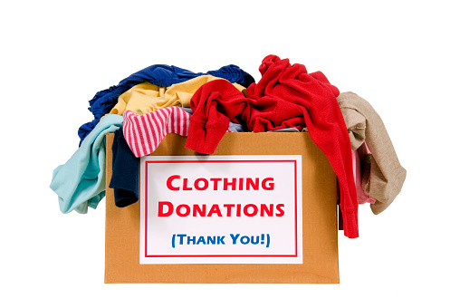
Faith Church (400 N. Temple Blvd. Temple, PA 19560) is Collecting Gently Used Clothing and other items, listed below.
Date: Saturday, April 17, 2021
Time: 10 a.m. – 1 p.m.
Our parking lot is located off 4th Avenue (North Temple Blvd./4th Avenue Temple, PA)

Contact Church Office w/questions:
610-929-1895 or secretary@wearefaithec.com
We will be collecting your donations on the parking lot, behind the church. Just drive up and drop off.

We are accepting:
Wearable, Usable Clothing (Men’s, Women’s, and Children’s) Shoes (Please bag shoes separately), Belts & Handbags, Stuffed Animals (24 inches or smaller), Hard Toys (24 inches or smaller), Bikes & Scooters.

Non-Acceptable Items: Sports equipment, board games, books, puzzles, pots and pans, electrical devices, glassware, large toys (over 24 inches), highchairs and cribs.
PLEASE put all items; that you are donating, into tightly tied plastic trash bags.
Thank You For Your Support!

